Kuwait Shooting Federation

**The Kuwait Shooting Federation has the pleasure to host the 4th Asian Air Gun Championships, to be held in Kuwait, and to invite all members of the Kuwait Shooting Federation, to participate from the 17th to the 23rd of October, 2011.**

2011

IT SECTION

Kuwait Shooting Club

Last Update 12/10/2011

**General Information**

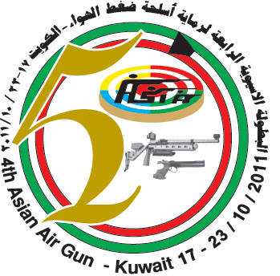

**General Information**

H.H. Sheikh/ Sabah Al-Ahmad Al-Jaber Al-Sabah Shooting ranges complex is located in Sulaibiya area between 30 – 45 minutes from Kuwait city.

**Target machines and Results:**

The Competitions will take place in the Sheikh Sabah Al-Ahmad Olympic Range complex at Sulaibiya, Kuwait.

The Olympic rifle and pistol ranges are equipped with Sius-Ascor electronic targets and scoring equipment.

The range comprises 10m – 60 firing points.

In addition, there is a separate Olympic Finals range.

.

|  |  |
| --- | --- |
| **Weather** |  |
| CA66FWP9.jpg | Temperature in Kuwait in OCT., During the championships is between 35°C day time and 18°C night time. There is no Possibility for rain fall during October. |

|  |  |  |  |  |  |  |  |  |  |  |  |  |  |  |  |  |  |  |  |  |  |  |  |  |  |  |  |  |  |  |  |  |  |  |  |  |  |  |  |  |  |  |  |  |  |  |  |  |  |  |  |  |  |  |  |  |  |  |  |  |  |  |  |  |  |  |  |  |  |  |  |  |  |  |  |  |  |
| --- | --- | --- | --- | --- | --- | --- | --- | --- | --- | --- | --- | --- | --- | --- | --- | --- | --- | --- | --- | --- | --- | --- | --- | --- | --- | --- | --- | --- | --- | --- | --- | --- | --- | --- | --- | --- | --- | --- | --- | --- | --- | --- | --- | --- | --- | --- | --- | --- | --- | --- | --- | --- | --- | --- | --- | --- | --- | --- | --- | --- | --- | --- | --- | --- | --- | --- | --- | --- | --- | --- | --- | --- | --- | --- | --- | --- | --- |
| |  | | --- | | [**16**](http://www.weather.com/weather/wxdetail/KUXX0002?dayNum=3) |  |  |  | | --- | --- | | http://image.weather.com/web/common/wxicons/25/32.gif?12122006 | | | Hi | **39°C** | | Lo | **22°C** |  |  | | --- | | Precip | | **0 %** |  |  | | --- | |  | | |  | | --- | | [**17**](http://www.weather.com/weather/wxdetail/KUXX0002?dayNum=4) |  |  |  | | --- | --- | | http://image.weather.com/web/common/wxicons/25/32.gif?12122006 | | | Hi | **40°C** | | Lo | **21°C** |  |  | | --- | | Precip | | **0 %** |  |  | | --- | |  | | |  | | --- | | [**18**](http://www.weather.com/weather/wxdetail/KUXX0002?dayNum=5) |  |  |  | | --- | --- | | http://image.weather.com/web/common/wxicons/25/32.gif?12122006 | | | Hi | **39°C** | | Lo | **19°C** |  |  | | --- | | Precip | | **0 %** |  |  | | --- | |  | | |  | | --- | | [**19**](http://www.weather.com/weather/wxdetail/KUXX0002?dayNum=6) |  |  |  | | --- | --- | | http://image.weather.com/web/common/wxicons/25/32.gif?12122006 | | | Hi | **36°C** | | Lo | **18°C** |  |  | | --- | | Precip | | **0 %** |  |  | | --- | |  | | |  |  | | --- | --- | | [**20**](http://www.weather.com/weather/wxdetail/KUXX0002?dayNum=7) |  |  |  |  | | --- | --- | | http://image.weather.com/web/common/wxicons/25/32.gif?12122006 | | | Hi | **33°C** | | Lo | **16°C** |  |  | | --- | | Precip | | **0 %** |  |  | | --- | |  | | |  | | --- | | [**21**](http://www.weather.com/weather/wxdetail/KUXX0002?dayNum=8) |  |  |  | | --- | --- | | http://image.weather.com/web/common/wxicons/25/32.gif?12122006 | | | Hi | **32°C** | | Lo | **16°C** |  |  | | --- | | Precip | | **0 %** |  |  | | --- | |  | | |  | | --- | | [**22**](http://www.weather.com/weather/wxdetail/KUXX0002?dayNum=9) |  |  |  | | --- | --- | | http://image.weather.com/web/common/wxicons/25/34.gif?12122006 | | | Hi | **33°C** | | Lo | **16°C** |  |  | | --- | | Precip | | **0 %** |  |  | | --- | |  | |
| |  | | --- | | **23** |  |  | | --- | | AVERAGES |  |  |  | | --- | --- | | Hi | **33°C** | | Lo | **18°C** |  |  | | --- | | RECORDS |  |  |  | | --- | --- | | Hi | **-** | | Lo | **-** | | |  | | --- | | **24** |  |  | | --- | | AVERAGES |  |  |  | | --- | --- | | Hi | **33°C** | | Lo | **18°C** |  |  | | --- | | RECORDS |  |  |  | | --- | --- | | Hi | **-** | | Lo | **-** | | |  | | --- | | **25** |  |  | | --- | | AVERAGES |  |  |  | | --- | --- | | Hi | **32°C** | | Lo | **18°C** |  |  | | --- | | RECORDS |  |  |  | | --- | --- | | Hi | **-** | | Lo | **-** | | |  | | --- | | **26** |  |  | | --- | | AVERAGES |  |  |  | | --- | --- | | Hi | **32°C** | | Lo | **17°C** |  |  | | --- | | RECORDS |  |  |  | | --- | --- | | Hi | **-** | | Lo | **-** | | |  |  | | --- | --- | | **27** |  |  |  | | --- | | AVERAGES |  |  |  | | --- | --- | | Hi | **32°C** | | Lo | **17°C** |  |  | | --- | | RECORDS |  |  |  | | --- | --- | | Hi | **-** | | Lo | **-** | | |  | | --- | | **28** |  |  | | --- | | AVERAGES |  |  |  | | --- | --- | | Hi | **31°C** | | Lo | **17°C** |  |  | | --- | | RECORDS |  |  |  | | --- | --- | | Hi | **-** | | Lo | **-** | | |  | | --- | | **29** |  |  | | --- | | AVERAGES |  |  |  | | --- | --- | | Hi | **31°C** | | Lo | **17°C** |  |  | | --- | | RECORDS |  |  |  | | --- | --- | | Hi | **-** | | Lo |  | |

**Emergency Numbers**

|  |  |
| --- | --- |
| [http://t2.gstatic.com/images?q=tbn:ANd9GcS1nYE7FLcwGHNAfzjQSuABpyXztUOvFQswCA37e0_mvK1Sj11WJ5EQ9uA](http://www.google.com.kw/imgres?q=%D8%A7%D8%B3%D8%B9%D8%A7%D9%81&um=1&hl=ar&sa=N&biw=1440&bih=764&tbm=isch&tbnid=oP9SyNkhOt4QyM:&imgrefurl=http://www.tangawi.com/vb/t13942.html&docid=ZOHWBsOa-hCKbM&w=500&h=255&ei=1HxrTsmyMc-yrAePr42jBQ&zoom=1&iact=rc&dur=459&page=4&tbnh=98&tbnw=192&start=74&ndsp=24&ved=1t:429,r:2,s:74&tx=135&ty=53) | [http://t1.gstatic.com/images?q=tbn:ANd9GcSbfmvy2Y1A9DRpbLMx-F72NifAk8RKQhnam6BjFS34r8JTDDPt](http://www.google.com.kw/imgres?q=%D8%AA%D9%84%D9%8A%D9%81%D9%88%D9%86&um=1&hl=ar&sa=N&biw=1440&bih=718&tbm=isch&tbnid=ZKWtAUEGIFap9M:&imgrefurl=http://kareemazmy.blogspot.com/2008/11/blog-post_18.html&docid=IABpjrFxrZRUaM&w=270&h=264&ei=1YBrTp3oBovIrQfe74jOBQ&zoom=1)**112** |
| [http://t0.gstatic.com/images?q=tbn:ANd9GcQr9Gk89yw74MqtktBqkS1pnMGOcVZvKpmAAEpk45UzDTXmJc-ydw](http://www.google.com.kw/imgres?q=police+clip+art&um=1&hl=ar&biw=1440&bih=718&tbm=isch&tbnid=tP5IXeM2KDk2rM:&imgrefurl=http://www.cartoon-clipart.com/cartoon_clipart_images/black_and_white_police_vehicle_withe_police_on_the_side_and_red_light_on_top_0515-1005-3104-3439.html&docid=XUGlP8XjzwfzmM&w=300&h=181&ei=OH1rTuGLDIS4rAe7nsCyBQ&zoom=1) | [http://t1.gstatic.com/images?q=tbn:ANd9GcSbfmvy2Y1A9DRpbLMx-F72NifAk8RKQhnam6BjFS34r8JTDDPt](http://www.google.com.kw/imgres?q=%D8%AA%D9%84%D9%8A%D9%81%D9%88%D9%86&um=1&hl=ar&sa=N&biw=1440&bih=718&tbm=isch&tbnid=ZKWtAUEGIFap9M:&imgrefurl=http://kareemazmy.blogspot.com/2008/11/blog-post_18.html&docid=IABpjrFxrZRUaM&w=270&h=264&ei=1YBrTp3oBovIrQfe74jOBQ&zoom=1)**112** |
| [http://t1.gstatic.com/images?q=tbn:ANd9GcQo7lpu86wmm4geiSN7bYaUOS_CIpNBi6Z2EMUMbGhBgEF8kk-2](http://www.google.com.kw/imgres?q=%D9%85%D8%B7%D8%A7%D9%81%D9%8A&um=1&hl=ar&biw=1440&bih=718&tbm=isch&tbnid=kkjNUkRZRiFcYM:&imgrefurl=http://www.q8yat.com/t525617.html&docid=RjnSWJ--HxoVxM&w=500&h=378&ei=u39rTqnuGobxrQeA_szFBQ&zoom=1) | [http://t1.gstatic.com/images?q=tbn:ANd9GcSbfmvy2Y1A9DRpbLMx-F72NifAk8RKQhnam6BjFS34r8JTDDPt](http://www.google.com.kw/imgres?q=%D8%AA%D9%84%D9%8A%D9%81%D9%88%D9%86&um=1&hl=ar&sa=N&biw=1440&bih=718&tbm=isch&tbnid=ZKWtAUEGIFap9M:&imgrefurl=http://kareemazmy.blogspot.com/2008/11/blog-post_18.html&docid=IABpjrFxrZRUaM&w=270&h=264&ei=1YBrTp3oBovIrQfe74jOBQ&zoom=1)**112** |

**Services**

|  |  |
| --- | --- |
|  | |
| C:\Documents and Settings\Ayman\My Documents\My Pictures\1.jpg | Catering: An open Free Lunch Buffet is available in the main restaurant with international cuisine variety 11:00 – 16:00 |
| C:\Documents and Settings\Ayman\My Documents\My Pictures\22.jpg | Café shops and cold meal snacks available with reasonable prices in the ranges, main restaurant & Rest area’s 1+2 |
| C:\Documents and Settings\Ayman\My Documents\My Pictures\4.jpg | Money exchange service will be provided in the Registration building grand hall. |
| C:\Documents and Settings\Ayman\My Documents\My Pictures\5.jpg | Free bottled drinking water available. |
| C:\Documents and Settings\Ayman\My Documents\My Pictures\6.jpg | Clinic opens daily during the competition from 08:00 – 19:00. |
| C:\Documents and Settings\Ayman\My Documents\My Pictures\3.jpg | Free regular transportation to and from Official hotels and ranges will be provided during the championships. |
| taxi.jpg | Taxi Service Available |
| C:\Documents and Settings\Ayman\My Documents\My Pictures\7.jpg | For any inquiries or additional information please contact the help desk at the ranges.  Tel.: (965) 1840040 Ext.232 PR Office in your hotel. |
| CAGPQZCL.jpg | Free WI-FI Internet Service will be provided in All Area’s |

**Committees**

|  |  |  |  |
| --- | --- | --- | --- |
| No | Name | Description | Mobile |
| 1 | **Technical Delegate** | | **99620951** |
|  | **Mr. Jasni Sharri** | **Championship Director** | **90959849** |
|  | **Mr. Salim Aldahish** | **Assistant Championship Director for Technical matters** | **99641289** |
|  | **Mr. Abdulrrazaq Altayar** | **PR Committee Head** | **97959366** |
|  | **Mrs. Leena Almahmoud** | **Help Desk**  **Information Center** | **99036381**  **1840040 Ext 323** |
|  | **Mr. Zaid Al Thfiri** | **Range and Security Manager** | **99641004** |
|  | **Mr. Moien Maklad** | **Transportation Committee Head** | **97864060** |

**Accommodation**

|  |  |
| --- | --- |
| **Hotel The Regency**  **Tel. +965 2576 6666 Fax. +965 2576 6610**  **Help Desk: 99552275 – 99612083 - 66111772** | **http://www.hotels-booking.org/Images/Kuwait/Kuwait/120/The_Regency.jpg** |
| **Hotel Ramada Kuwait**  **Tel: +965 1821111 Fax: +965 248 0055**  **Email :** [**reservation@ramadakuwait.com**](mailto:reservation@ramadakuwait.com)  **Help Desk: 97666986 - 66345556** | **http://www.kuwait-hotels.org/wp-content/uploads/2011/05/%D9%81%D9%86%D8%AF%D9%82-%D8%B1%D9%85%D8%A7%D8%AF%D8%A7-%D8%A7%D9%84%D9%83%D9%88%D9%8A%D8%AA.jpg** |
| **Hotel Copthorn Al-Jahra**  **Tel. +965 2459 0000 Fax. +965 2459 0005**  **E-mail:** [**admin@cop-aljahra.com**](mailto:admin@cop-aljahra.com)  **Help Desk: 99479895 – 97517779 - 66742955** | **[http://t1.gstatic.com/images?q=tbn:ANd9GcRG9kLuLMgOx1NSrPUrjW1w8NnGSdvDSPKLn_J6oK0ML7e9G6nDzQ](http://www.google.com.kw/imgres?q=%D8%B3%D9%84%D9%8A%D9%84+%D8%A7%D9%84%D8%AC%D9%87%D8%B1%D8%A7%D8%A1&hl=ar&safe=off&sa=X&biw=1440&bih=703&tbm=isch&prmd=imvnsfd&tbnid=dmIdeL1r3w4IfM:&imgrefurl=http://vb.kuwait777.com/thread129984.html&docid=2SOUU-Rsa_nD5M&w=284&h=165&ei=IMeSTuK5HcnrsgaY973nCA&zoom=1)** |
| **Continental - Farwaniya**  **Tel. +965 247 36700 Fax. +965 247 12793**  **Help Desk: 55244554 - 99894079** | **[http://www.kcontl.net/images/kch-f-p0s.jpg](javascript:openIT('photo.asp?photo=kch-f-p0.jpg&title=Continental%20Suite%20Farwania',%20450,%20500,%20'wname');)** |
| **Kuwait Continental Hotel**  **Tel. +965 252 7300 Fax.+965 252 9373**  **Help Desk: 97564345** | فندق كويت كونتيننتال Kuwait Continental Hotel |

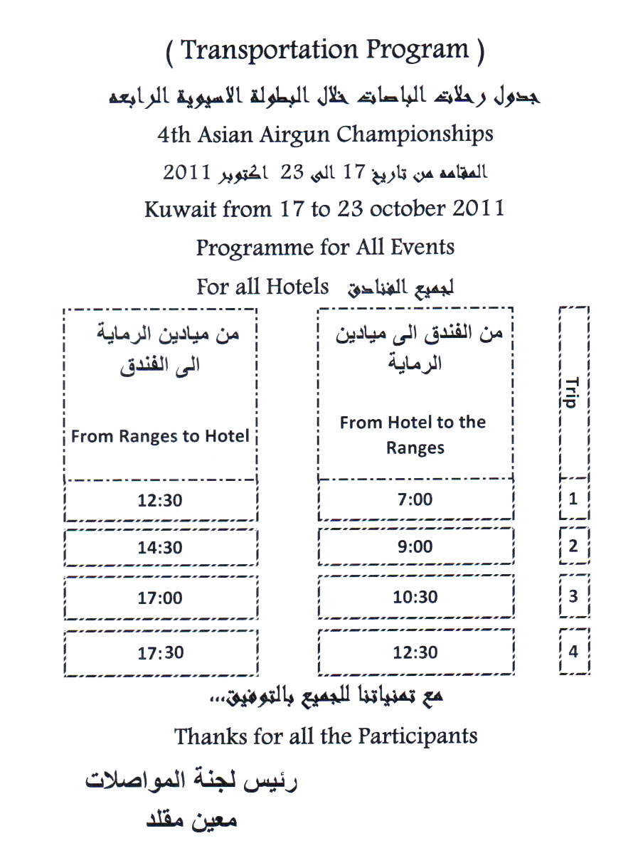



**From Ranges to Hotels**

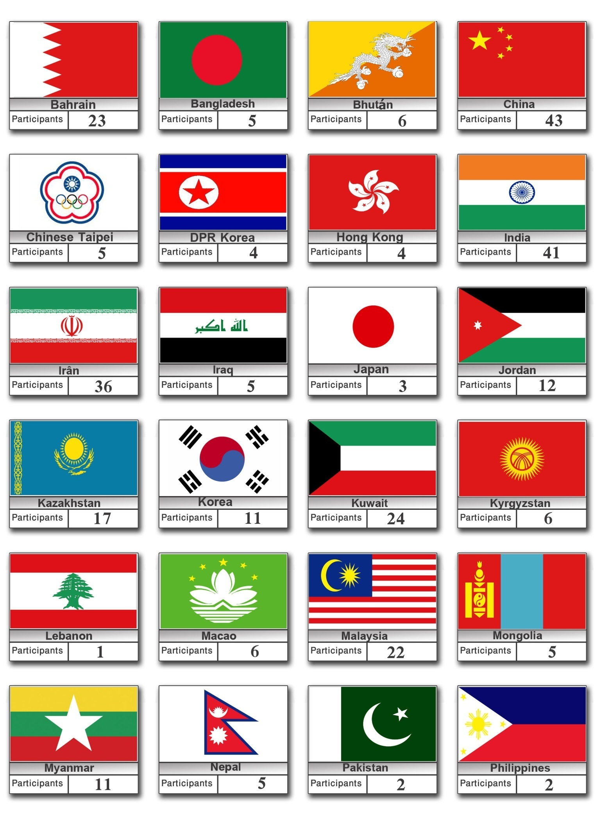

**Countries & Participants**

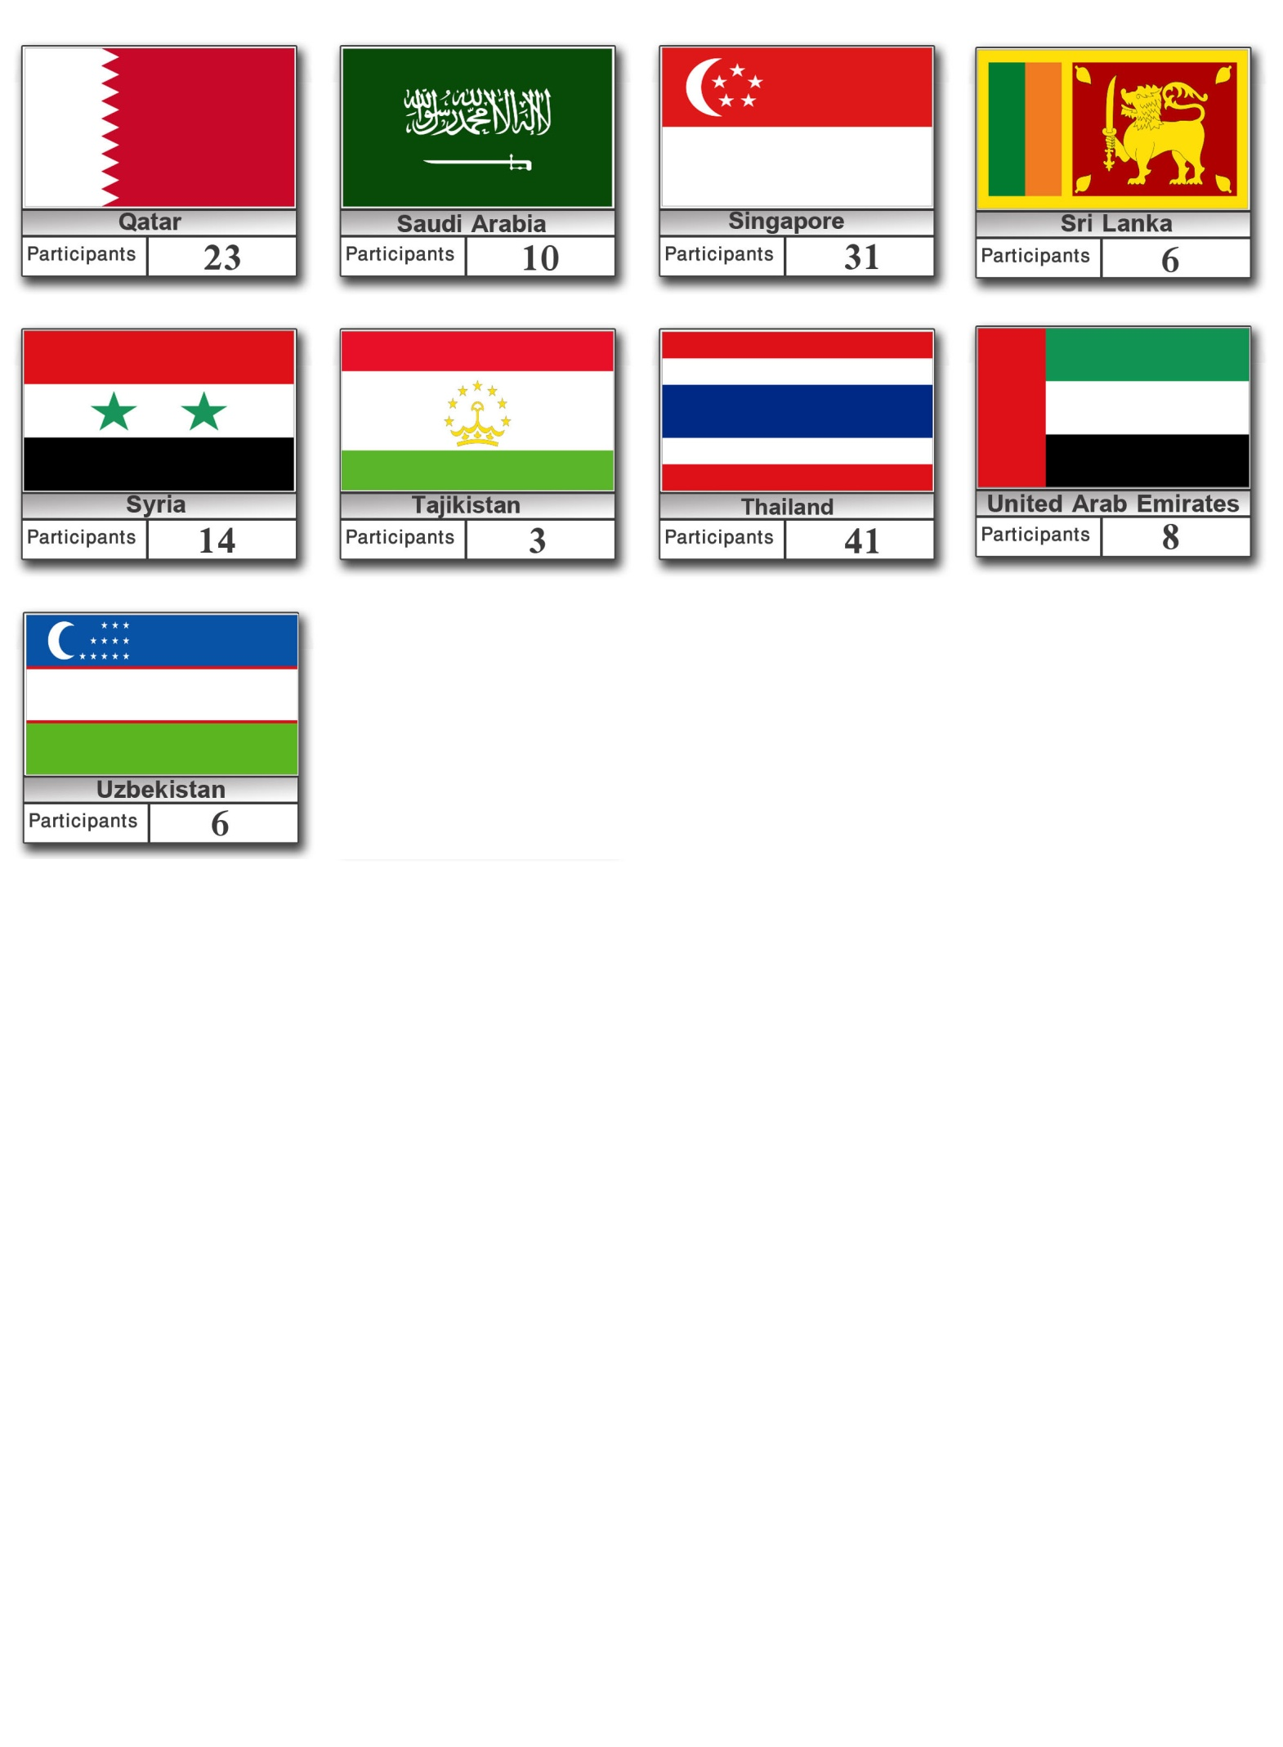

**Telephone Numbers of Embassies**

[](http://www.google.com.kw/imgres?q=embassies&um=1&hl=ar&biw=1440&bih=718&tbm=isch&tbnid=YLk06Q2ODZhVRM:&imgrefurl=http://www.greek-islands.us/greece/embassies-in-greece/&docid=Ud4nlzCHuXn-tM&w=900&h=200&ei=JI5rTpggh-itB9yv5a8F&zoom=1)

|  |  |  |  |
| --- | --- | --- | --- |
| **الجمهورية الإندونيسية** | **+965 24839927** | http://www.flags.net/images/smallflags/INDN0001.GIF | **The Republic of Indonesia** |
| **جمهورية أوزبكستان** | **+965 25376603** | [http://www.flags.net/images/smallflags/UZBK0001.GIF](http://www.flags.net/UZBK.htm) | **The Republic of Uzbekistan** |
| **الجمهورية الإسلامية الإيرانية** | **+965 25350246** | [http://www.flags.net/images/smallflags/IRAN0001.GIF](http://www.flags.net/IRAN.htm) | **The Islamic Republic of Iran** |
| **جمهورية باكستان الإسلامية** | **+965 25327649** | [http://www.flags.net/images/smallflags/PAKS0001.GIF](http://www.flags.net/PAKS.htm) | **The Islamic Republic of Pakistan** |
| **جمهورية بنغلادش الشعبية** | **+965 25316042** | [http://www.flags.net/images/smallflags/BNGL0001.GIF](http://www.flags.net/BNGL.htm) | **The People's Republic of Bangladesh** |
| **مملكة بوتان** | **+965 22516640** | [http://www.flags.net/images/smallflags/BHUT0001.GIF](http://www.flags.net/BHUT.htm) | **The Kingdom of Bhutan** |
| **مملكة تايلند** | **+965 25317530** | [http://www.flags.net/images/smallflags/THAL0001.GIF](http://www.flags.net/THAL.htm) | **The Kingdom of Thailand** |
| **جمهورية سيرلانكا** | **+965 25339140** | [http://www.flags.net/images/smallflags/SRLA0001.GIF](http://www.flags.net/SRLA.htm) | **The Republic of Sri Lanka** |
| **جمهورية الصين الشعبية** | **+965 25333340** | [http://www.flags.net/images/smallflags/CHIN0001.GIF](http://www.flags.net/CHIN.htm) | **The People's Republic of China** |
| **الفلبين** | **+965 25349099** | [http://www.flags.net/images/smallflags/PHIL0001.GIF](http://www.flags.net/PHIL.htm) | **Philippines** |
| **جمهورية كوريا** | **+965 25351571** | http://www.33ff.com/flags/XL_flags/Korea_flag.gif | **The Republic of Korea** |
| **جمهورية كوريا الديمقراطية الشعبية** | **+965 25329462** | http://aceproject.org/ace/regions-en/images/flags/KP.gif | **The Democratic People's Republic of Korea** |
| **ماليزيا** | **+965 22550394** | [http://www.flags.net/images/smallflags/MALS0001.GIF](http://www.flags.net/MALS.htm) | **Malaysia** |
| **منغوليا** | **+965 99674826** | [http://www.flags.net/images/smallflags/MONG0001.GIF](http://www.flags.net/MONG.htm) | **Mongolia** |
| **ميانمار الإتحادية** | **+965 25240736** | [http://www.flags.net/images/smallflags/MYAN0001.GIF](http://www.flags.net/MYAN.htm) | **The Federal Myanmar** |
| **جمهورية نيبال الفيدرالية** | **+965 67606442** | [http://www.flags.net/images/smallflags/NEPA0001.GIF](http://www.flags.net/NEPA.htm) | **The Federal Republic of Nepal** |
| **جمهورية الهند** | **+965 22550379** | [http://www.flags.net/images/smallflags/INDA0001.GIF](http://www.flags.net/INDA.htm) | **The Republic of India** |
| **اليابان** | **+965 25309400** | [http://www.flags.net/images/smallflags/JAPA0001.GIF](http://www.flags.net/JAPA.htm) | **Japan** |

